- Search in Rotated Sorted Array

Question :[ https://leetcode.com/problems/search-in-rotated-sorted-array/submissions/2009662612/?envType=daily-question&envId=2026-05-22 ]

Solution :

To solve this problem in O(log n), we use Binary Search.
The main idea is:
- In a rotated sorted array, one half is always sorted.
- Check which half is sorted.
- Decide whether the target lies in that half or the other half.

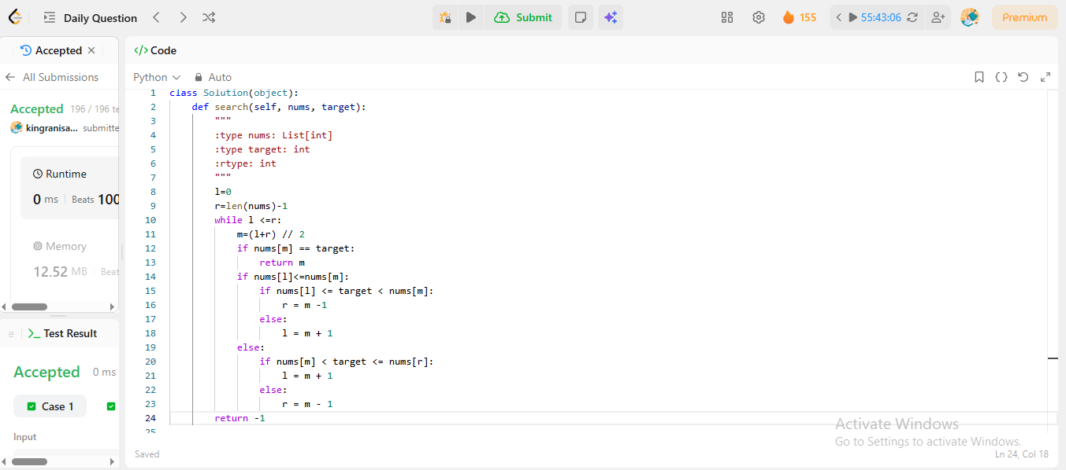

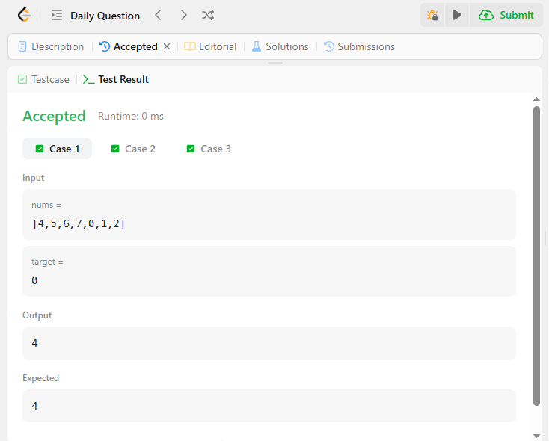


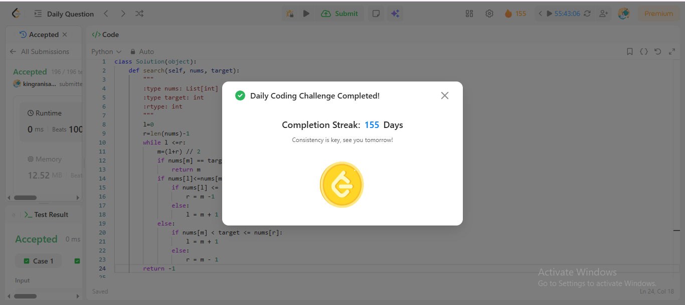

Time & Space Complexity
Time is O(log n)
Space : O(1)

